**Calculate the initial horizontal velocity achieved by the sprinter after pushing off from the blocks.** Watch the slowed-down biomechanical visualization of this sprint start by clicking on the link [here](https://drive.google.com/file/d/1QBe26qrTCAile8gi8zNb7KBYlUd4c2Jy/view?usp=sharing).You will need to use the attached excel sheet (Sprint_StartData_Q2.xlsx) which contains the measured ground reaction forces in the anterior-posterior direction under each foot to answer this question.

[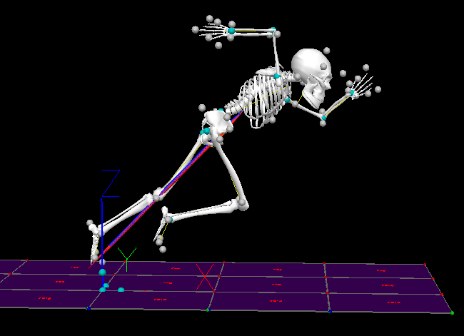](https://drive.google.com/file/d/1QBe26qrTCAile8gi8zNb7KBYlUd4c2Jy/view?usp=sharing)

**Hint:** You will need to estimate the area under the force-time curves in excel to get the impulse produced by each leg using the trapezium rule. Then apply the impulse-momentum relation to get the velocity resulting from the total impulse. The mass of the individual is 60.7 kg. In the excel file and the sprint video, notice that the sprinter starts applying force to the block at 4 s and finishes at 4.428 s.

Report the following:

1. Report the net anterior-posterior impulse for the back foot: _________
   1. Explain how you found the number here.
2. Report the net anterior posterior impulse for the front foot: _________
   1. Explain how you found the number here.
3. Report the total anterior-posterior impulse: ________
   1. Explain how you found the number here.
4. Report the resulting initial anterior-posterior velocity at the moment when the sprinter leaves the block (m/s): ____________
   * Explain how you found the number here.

**Please attach the .xlsx file with your area calculations to your answer so that the evaluators can quickly assess the accuracy of your work!**